Today is the first day of my second internship in the Bosch headquarters office in Maltepe- İstanbul. I have started the day with writing my recommendations to new developers on Excel automation tasks:

“”” Hello, if you are working in automation related with Excel files, I have some suggestions:

- Use reversed() to delete rows from bottom to top rows. Because if we start from top rows

and we continue to bottom while deleting, the total row number changes each operation and

with this change the index numbers change. For example you delete row 7 instead of row 5.

- In my opinion, using VBA is a very practical tool. You do not need to make a executable

file (.exe) like in python for users to start the program and there are different type of

widgets (buttons, sliders..) to insert directly into sheet or ribbon. But some VBA

operations (like going row by row) may be slower than Python-openpyxl and may not respond

in some times. Also, programming in Python is easier to understand than VBA in my opinion.

- Please be careful to not to accidentally delete worksheets, workbooks or overwrite. For

example, in development phase make new files for outputs for comparison. (Not overwrite)

Please reach me when I show as available (in Skype) for discussions, feedback etc., ”””

After writing these things, I would like to also add that using Excel formulas is very fast to iterate through data. Other methods take some time to get operated and show data, while Excel is very fast. One of the reasons may be that the data is inside excel, thus developer do not need to use external.

I also, got transferred to a new department and have a supervisor on Germany. Previously, I was doing automation tasks via Python, VBA, MATLAB. But now, I need to work with Excel internal tools. These tools include Excel formulas, pivot tables, power query, power pivot systems. I also do not use SQL for now, because some aim of these new tasks require Excel usage.

There are different tools that my new department is working on, all tools act for connected or unique purposes. All tools do not use Excel, for example in some cases SQL server is getting used. In some cases, artificial intelligence technologies such as machine learning is used to generate insights.

I do have lack of knowledge working with Excel formulas and pivot tables. Thus in many following days, I have worked on these knowledge topics to decrease my lack of knowledge. So, technical information about formulas and pivot tables are in following pages. When finished, I aim to write what I had done on the given task from my supervisor.

To talk about the task 1 in a small scale, the following information is non confidential:

* There are four tables. These tables have common columns.
* All tables have one common column, the common column is id - related.
* I need to make a connection between tables.
* After connection, I need to get row count of matches for some conditions.
* At the end of the task, I need to report the results to my supervisor.

Today is the second day of my second internship in Bosch headquarters office in Maltepe- İstanbul. Today, I have worked on formulas knowledge. I have studied on a training on Udemy. Transcript:

Now let's take a look at another brand new Excel power lookup function.The XLOOKUP function. The difference between XLOOKUP and FILTER is that XLOOKUP returns one match result, whereas FILTER returns all match results. Now, what's the difference between XLOOKUP and VLOOKUP? Well, the XLOOKUP function was introduced as the more flexible version of VLOOKUP. If you've been working with VLOOKUP for a while at work in your files, you've probably come across some restrictions.The XLOOKUP function doesn't have these restrictions and we're going to do some examples here. So we've set up this case the same as our VLOOKUP example. This way you can see the difference between the two functions easier. So I have the name and yearly salary of these people.

I want to find their department and bonus. On another sheet, my master data sheet, I have the full employee information with all names, division and department and the bonus scheme here. So notice here I have the same setup like in the VLOOKUP example where we have name first, then division and department. Now let's solve this with the XLOOKUP function. So we start off with XLOOKUP.

First argument is the lookup value, just like VLOOKUP. What are we looking for? We're looking for this name. Next is the Lookup Array. Now this is where things are different. When we compare this to VLOOKUP. Because for VLOOKUP, we just had one array that we selected. For XLOOKUP we have a Look-Up array and a return array. The fact that these are separated makes this formula much more flexible than VLOOKUP. I'm going to show you why in a second. So in this case, our Look-Up Array is the range where this name is sitting in. That's in our master data tab and it's sitting right here. So all I have to do is to highlight this one range. Just the range this value is sitting in. The next argument here is the return array. What do I want to get back? Well, we went to get department back and that's sitting right here. So notice the difference with VLOOKUP. We just selected one whole range. Our lookup range had to be on the left hand side. With XLOOKUP we have two separate ranges and we don't have to highlight the stuff that we don't need. So in this case, I'm not interested in division. I just want department back. I don't have to include it. The rest of these are optional arguments. Another great advantage of XLOOKUP is I don't need to say that I want to look for an exact match. With VLOOKUP we always had to select false if you wanted an exact match. Because default was always set to true, which would give us an approximate match. With XLOOKUP default is an exact match. That's all I need to do. Press enter and I have my results. So, Paul Garza works in the sales department.

Let's just quickly double check. That's Paul Garza. And that's the sales department. The formula itself is much easier to write. If I want to drag this down I have to make sure I fix these. I'm just gonna highlight these, press F4, press enter and send the formula down. Now, let's take a look at those optional arguments and when we could use them. So the first optional argument here is, if not found. Remember, with VLOOKUP what did we get if our lookup value wasn't found in our master data? We'd get the #NA! error. And we had to wrap our function inside an IFERROR function or IFNA function. With XLOOKUP, we can take care of that inside the formula. If it doesn't find something we can say does not exist or we can put any result that we want.

Thus, I learned with xlookup we may look for a value on a cell inside a cell range, then if it is found, we may take another cell’s value in the same row with match cell. With relative referencing, we may apply this formula downwards, to apply as much as possible to cells.

Today is the third day of my second internship in Bosch headquarters office in Maltepe - İstanbul. Today, I have continued my Udemy training on excel, namely filter function. The transcript followed:

Now, let's take a look at my favorite new dynamic here function, the FILTER function. This is a power lookup function because it allows you to return multiple match results instead of just the first results.

Because just think about the VLOOKUP function. It always returns the first match. With FILTER

you can return all matches. In Excel there are ways to get all match results. You can use a complex legacy array formula or you can use pivot tables. You can also use the filter feature. Pivot tables and the filter feature aren't dynamic. So every time your source data change, you'd have to refresh your filter or refresh your pivot table. When you use the FILTER function, everything is automatic. Source data change, results are going to change. So let's do a quick example. This data set has already been converted to a table. It has the name TableS3. I want to get a filtered list based on the division that I type in here, and you can make this into a dropdown as well. Just like we learned in the previous lectures. In this case, we're just going to type it in. Now, if I type in productivity, I don't just want to get the first result. I want to get all results. And the results I want to get back, let's say is department name and salary. Just to make sure that we do it correctly in the first stage, let's also include division.

And then we can update our formula. So we start of the formula by typing in filter. The first mandatory argument is the array. This is basically the result that you want to get back. So we said in the first example, let's include the division to make sure we've typed the formula in correctly. That's basically our entire table. Next argument is the include argument. This is your filter value. The filter value is this one, right? I want to filter this where I have productivity. But Excel has to know in which column do you have productivity. The way you provide it with this argument is to first select the column where this value sitting in, it's sitting in the division column and checking if it's equal to your filter value.

This is basically a logical test in Excel. What it returns is a set of true and false values. And we can see that if I just highlight this and press F9 to see what's behind the formula, you can see false. True. So false is wherever it's not equal to productivity. The trues are where it's equal to productivity. The include argument includes everything that's a true. To make sure I don't hardcode this is the formula I'm going to press control Z to go back. The last argument of FILTER is optional. And that's what it should return, if it doesn't find that value in your data set. If you don't put anything here and it doesn't find the value, it's going to give you a new error. It's the hash calc error. And we can see that in a second. So the first example, I'm just going to omit that and press enter. I get my results for just the productivity division. Now, this is dynamic. If I change this to game it updates to show me the results in the game division. I don't need game sitting here. I just put that to make sure that our results are correct. So let's omit that from here. So from our array instead, let's include department all the way to salary and press enter. It'd be nice to have these formatted properly. So let's apply the formatting to this. Since I'm expecting my results to change So sometimes it's bigger, sometimes it's smaller.

I'm just going to apply the formatting to more cells. Now what happens if I have a new division?

So let's say I have the health division. Let's add the finance department to that.

After training, we may see that I need to use FILTER function, when I want to filter a table (rows) with multiple conditions on multiple columns. If I want to do this with XLOOKUP, I need to write multiple formulas, with FILTER we may filter a table/dataset with multiple conditions unique to a specific column. Today passed with my FILTER function training.

Today is the fourth day of my second internship in Bosch headquarters office in Maltepe - İstanbul.

Today, I have continued my Udemy training on excel, namely filter function. The transcript followed:

Now, let's talk about Excel's new UNIQUE function. What this function does is it returns a list of values that have no duplicates in them. And because it's a formula, it's dynamic. Your raw data changes, your spilled range will change as well. It's a super easy function to use. So let's do an example here. We want to get a list of divisions that have no duplicates in them. So we want to get a distinct list. All we have to do is type in UNIQUE. We see it into dropdown press tab to bring it to the formula bar. Now, notice that this function only has one mandatory argument, and that's the array.

Basically the range for which you want to get unique values on. The other arguments by_col

and exactly_once which I'm going to cover in a second are optional because they're in square brackets.

So since we want to get a unique list of division, let's go and highlight our range, close bracket, press

enter and our results spill. And we get our list back without duplicates. Now, what happens if we have a new division added somewhere in the middle? So I'm just going to insert a health division here, notice that it automatically gets added to the spilled range. Now, in the previous lecture, we said that spilled ranges work perfectly well with Excel tables. So let's turn this dataset into an official Excel table. Just gonna click somewhere inside. Press Ctrl + T. Now, let's also go and change the table name to TableS for salary and add a 1 to the end. I turned this dataset into a table after I wrote my formula. What happens if I add something new to the bottom of this dataset? Is it going to show in this formula or not? Let's test this. Let's add a new division here. Let's just go up and see if it's added. It's added automatically because this range has recognized that the raw data has been turned into a table and it's actually expanding as the table expands. What if I delete this? Let's go back. It's gone. It changed from A36x to A35. So you can turn your data set later into a table as well. You don't have to do it before you start typing your formulas. Now, how about creating a dropdown for division? So, a data validation that has a unique list of these divisions. To insert a dropdown, let's go to data > Data validation. I'm gonna select list from here. And for source, I'm going to reference the list of my divisions. And because I want it to spill, I'm going to add the hash sign to the end and click on

Okay. And now I have a unique list for my divisions. And if something new gets added, it should automatically show in my dropdown. And it does. Can I directly use the unique formula inside data validation? Let's try that. Let's go back to data validation and change this to unique and reference the division column, close and press enter. The source currently evaluates to an error. So right now, as it stands in Office 365, you can't directly use these functions inside the data validation. But you can create helper cells in Excel and use the high sign to get the spilled range. This way you can get dynamic data validation lists. Now, what if you wanted to get a unique combination for division and department? You can do that with the UNIQUE function. You can give the function more than one column. So now, since this is a table, let's use the table referencing. I'm going to highlight these two, close bracket, press Enter. And that's the unique combination of the two columns.

After this training, I understood that we may use UNIQUE function with XLOOKUP to search for unique names in a column in a range. Also, while making relationships between tables many-to-many relationships are not supported. To resolve this issue, we may make a custom list from a common column - unique list and use this unique list to make one-to-many relationships between tables.

Today is the fifth day of my second internship in Bosch headquarters office in Maltepe - İstanbul.

Today, I have continued my Udemy training on excel, namely sort function. The transcript followed:

Next in line, are Excel's SORT and SORTBY functions. These functions help you dynamically sort with a formula. Now, the first question you might have is what's the difference between the two? It's gonna become obvious throughout this lecture when we cover an example for each. But as a quick summary SORT allows you to sort your values based on your results. And SORTBY allows you to sort your values based on a range that's not in your results. Now, when I first heard this, it didn't make sense to me until I saw an example. So let's start with the sort function. Before we tackle these here,

let's just try to sort the yearly salary right here. I've already turned this data set into an Excel table.

It's called TableS2. So to sort this list, we're just going to start off with the SORT formula > open bracket. Notice that the only mandatory argument is the array. So that's the range that we want to sort. Sort_index, sort_ order and by_column are optional. And we're going to see these in a second. I'm just going to highlight this column, close bracket, press enter, my results spill and they are sorted.

And in which order are these sorted? In ascending order. So that's the default for sort. No, because this is dynamic. If I add something here. So let's add 10,000 and press enter. These shifted down and 10,000 was added. If I change this to 60,000, 60,000 will be added right here. Okay. So now what if I wanted to have these in descending order? Then I can take advantage of the optional arguments.

The one I actually need is sort_order. But in between sort_ order and array, there is something called sort_index. That's something we're going to see in a second. But that comes in handy if you have many columns. And you want to sort by the second, third or fourth column, let's say. By default, Excel sorts based on the first column. So in this case, since I just have one column, I'm just going to skip that argument. Sort_order, Notice we see ascending, descending, default was ascending. If I want descending, I can type a minus one. The last optional argument is by column. And that's something we saw in the previous lecture. So if you want to sort your columns instead of rows, you need to put this argument to true. We don't need that in this case. So I'm just going to press enter and get my results in descending order. Okay, so that's how easy it is to use the SORT function.Now, let's take a look at these examples here.We want to get a sorted division list without duplicates.So in the previous lecture, we saw how we can use the UNIQUE function.First, let's get the unique list and then let's sort these.

So I'm just going to write the formula by working from the inside and then going out. First step, get

a unique list of division, go to division.I don't need any of these optional arguments. So I'm going to close bracket, press enter.That works fine.Now, second step is to get these sorted.So I'm going to put the unique formula inside the sort function. My array is this.I'm just going to close the bracket, press enter.I get the list in ascending order.If I wanted descending, what do I have to change?Not this one.

I need to change the sort order and put that to minus one.And that's my list.Right.So sort works on numbers and text.

After this training, I have learned that sorting is an important function to visualize data to viewers. It also make the presentation, data to easier to analyze by making individual items easier to find. We may sort alphabetically but we may also sort numbers. Sorting numbers help to see required data faster. We may also use SORT with UNIQUE function. For example, get a unique list, sort this list, then use this list in XLOOKUP function or use this list in FILTER function.

Today is the sixth day of my second internship in Bosch headquarters office in Maltepe - İstanbul. I have continued my training on merging data in power query. The transcript follows:

Now let's take a look at how we can merge data in power query. So basically merge data from different tables into one report. The great thing with using power query is that you can merge data from different places. They don't all have to be Excel tables in the same workbook. You can have a text file like we had in the previous lecture. You can have one table sitting in the workbook and other data source sitting somewhere else. As long as you can create a connection to it with power query you can merge these data sources together. What we're going to do in this lecture is to build on what we did in the previous one. In the previous lecture we imported a text file that had this information. This is a query that's connected to our text file. And we can see that by going to data, queries and connections,

that's our query. If we double click it, we open up power query and we can take a look at the steps that we applied here. Now what we're going to do is to merge this information together with this master data information. So let's say for the article code I actually want to use the description in my final pivot table. I don't have it in the source data. I just have the article code. I want to bring in the description in here as well. Now one way of doing this is to use the VLOOKUP function. After I imported the data here I can add a new column, use VLOOKUP and look up the data from the master data. Another way of doing this especially if you have a lot of data is to use power query. And the great thing is you can already add it as a part of your query steps. So every time you import this data you can already merge it and bring in the description. Let's go and set this up. First off, to be able to merge different queries together you actually have to create a query for each of your tables. So, for each of your data sets.

In this case I have the information sitting in an Excel worksheet. What I need to do before I bring this to power query is to transform this into an Excel table. I'm just gonna press Control+T. Or you can go to insert, and insert a table, table has headers. Let's go with Ok. Let's give this a name. I call it ArticleMaster. Press enter and let's take away the table style to go back to our original style. Now that this is a table, I'm going to create a query on this. So that every time this updates as well my query is going to update. Go to the data tab and click on From table. I can see the information in power query, Article Master is fine. I'm not transforming it and getting a different result. Otherwise I would change this name. But in this case I don't need to. I just double check the data types applied to these.

That's fine, and text is fine. So that's it. I basically don't have to do anything except I need to load it somewhere. But obviously I already have it in my worksheet. I don't want to load it there. So what I want to do is to go to close and load it to and only create a connection to this. Basically just keep this in memory and then click on ok. This means I have a query, every time this updates this information is going to get updated. My next step is to merge this query with this one. So I'm going to right mouset click on the first query and select merge. The dialogue box here shows me my first query which is this one and I want to merge it into Article Master. I have to select what is the connection between the two. The connection is the article code. Just select it and select the article code from the second table as well and then you can select the Join Kind. Now the default is left outer. Which means all from the first, matching from the second. Which is correct.

At later, I also saw the details of different types of data joining, I am planning to summarize my findings later in a page from past until now. Power pivot in my opinion is a very nice tool to analyze, transform the data. We may also set relationships in power query. It works without problem.

Today is the seventh day of my second internship in Bosch headquarters office in Maltepe - İstanbul. I have continued my training, especially in making power pivots. The transcript follows:

Now that we take a look at the benefits of pivot tables, let's take a look at how we can insert one. This is our sample data set. We have information on company, sales, customer information, the articles we are selling. This company is selling women's and men's clothing and accessories. The number of rejects. These were the number of items that were sent back. The quantity of sales and the sales in terms of U.S. dollars. This dataset goes to line 108. It's a smaller dataset. Now based on this,

We need to answer these two questions: Which company sells the most in terms of volume?

And also in terms of U.S. dollars. The advantage of using pivot tables is that you're not restricted

to the amount of data you have. You can have a small dataset like we have or a much larger dataset.

The pivot table is going to do all the summation and aggregation for you. Before we go ahead though and insert our pivot table. Let's quickly go through our checklist. Is our data organized in a list type of format? Yes, it is. We don't have any empty columns here and we don't have any summation rows in the middle of this data set. Do we have a title for each column here? This one doesn't have. Now I'm just going to assume that I missed this one and insert my pivot table and see the type of error we might get. First off, let's select the data set. To do that quickly we can use the shortcut key Control+A.

Now let's go to the Insert tab and insert a pivot table. We've already selected a range which we can see here. So if you hadn't selected anything you can do it at this stage. Then we have the ability to insert the pivot table on a new worksheet. If we go with this Excel will automatically create a new tab for us and insert the pivot table on that sheet. Or, we can select existing worksheets. Now remember I have a missing header here. I'm just going to go with okay and see what happens. I get this error. To create a pivot table you must use data as organized with labeled columns. I can't insert it until I add a column header for that. I'm going to go with cancel and add in my header. This looks like it's the code for this article. I'll just type in Article code for that. Now let's go and repeat our steps. Control+A, insert pivot table. I'll go with existing worksheet instead of a new worksheet. For location I'm going to insert it right here and click on Ok. First thing I get is a place holder for my pivot table report. And I get this pivot table fields items right here. Notice one thing. The names I see here are identical to my headers right here. Down here I get to decide how I want my table to look like. Notice also one thing. I immediately got two new tabs here an analyze tab and a design tab. These are active if I'm in my pivot table. The moment I click away those tabs disappear. I click in there, they appear. Now a lot of these features are features we're gonna be covering in the next lectures. One thing I want to bring your attention to is this "Fields list". If for any reason you close this pivot table fields. To get it back you can go to the analyze tab and click on this fields list. You can also drag this field list and bring it to where you want on your sheet. Now let's answer these questions. Which company sells the most?

Which categories do I need to be able to answer the first question. Well, I need company.

So what I'm going to do is place a check mark right beside it. What Excel automatically does is it tries to take a good guess at where you want this company to sit on your report.

Pivot tables in my opinion are amazing tools to analyze data. Adding filters to data and sorting is very practical. Also, viewer may see the filter values practically. We may also use pivot tables with other tools such as power pivot to further manipulate and transform data.

Today is the eight day of my second internship in Bosch headquarters office in Maltepe - İstanbul. I have continued my training on conditional formatting. I have followed the following transcript:

In the next two lectures we're going to take a look at Excel's conditional formatting. So until now, we took a look at basic Cell Formatting, we looked at number formatting. Now we're gonna see how we can influence the Cell Formatting based on a condition. Excel has a lot of easy to use inbuilt conditions. Let's take a look at these two in this lecture. And we're going to take a look at data bars and icon sets in the next lecture. First off, what is conditional formatting? I've actually used this throughout all the workbooks you've been using on the index page. Whenever you come to select an option from here. So let's say, you say, I've done this and I understand this. These cells turn green. If you select some other option like I want to review this later, they turn another color. This uses conditional formatting. To get to it and to see what type of rule I'm using here. You need to go and manage the rules. If you already have rules inside, you can go and manage them or edit them. And you see the different rules that are used here. To edit them you can click on it and take a look at the type of formatting that is used. Now in our example we're gonna start from scratch. So let's go to our conditional tab. Let's see some of these in-built functions that we have. Let's say for yearly salary

I want to highlight the cells that are greater than a specific value. So I'm going to go with this. Here I can directly input a value or I can use a cell reference. If I have some number sitting in a cell, I can reference it or let's just type something in. I'm going to go with a hundred thousand and then I can decide on the color that I want. So you have some built in custom formatting in there to make it easier for you. If you don't like any of these built in ones you can go to a custom format and decide on the fill color that you want, the font color and so on. And then click on Ok. Let's go back with this in-built one, click on OK, that's our formatting. So these were the numbers that are greater than 100,000.

If I change this one to 90,000 press enter, it's not highlighted anymore. That's the beauty of using conditional formatting. So in addition to this we had other options. We can do less than, between, equal to, if a text contains a certain word, duplicate values, and so on. So for our dates for example, let's go and see who started to work between the first of January 2018 to first of January 2019 and decide and the formatting and then click on OK. And that's our dynamic formats. If for some reason you want to go and change that formatting or clear the formatting, you do it from here. First highlight the area, go to clear rules and clear the rules from either the selected cells or from the entire sheet. Entire sheet means any conditional formatting you've used anywhere on this sheet will be deleted.

In this case I'm going to go and clear it from the selected cells. If you want to go and update the existing conditional formatting, you go to manage rules. You can see the existing formatting used. You can click to edit it, completely change the conditional formatting to another one. Or, you can add a new rule to this. You're not restricted to just one rule. You can select the cells that are greater than one hundred thousand and format them this way. But you can also add a new rule and go with format only cells that contain, if the cell value is less than, let's say thirty thousand. We want to format these in a red color, click on OK, and click on OK. And we see the two rules here.

Later on, I have learned that conditional formatting is a very capable tool to visualize data. One example is to make cells equal to 1 green, equal to zero yellow, equal to -1 red, like traffic lights. This was more related to fundamental knowledge, but I wanted to add this because personally I find the conditional formatting to be very autonomous and fun to use. (Also practical)

Today is the ninth day of my second internship in Bosch headquarters office in Maltepe - İstanbul. Today, I have continued my training (final day in this format ) on find feature on Excel. Transcript:

You're probably familiar with the find feature in office applications. Excel's Find feature is very similar except that we have additional benefits here that can come in really handy. So I'm gonna demonstrate them based on this dataset. The fastest way to get to the Find feature is to use a shortcut key Control+F. You can also get to it by going to the ribbon, from home, Find and select, and click on Find right here. All I have to do is type in what I'm looking for. So let's say I'm looking for Europe.

I'm gonna click on Find next and it finds the next occurrence of Europe on this data. So where is the next occurrence? It's right here. Click on it. It's gonna jump there. Now I can find all occurrences at once by clicking on Find all and I see the full list here. I can expand this just to get an idea of how many cells I have that include this word. And I could highlight them by holding down the control key and clicking on these. You can see them get highlighted here. I could highlight everything at once with the shortcut key Control+A. Now if I wanted to change this or I wanted to give this a background color I can just leave this dialog box, go up here and select a color. Because notice these are all still highlighted. I'm just gonna go with this yellow and everything is yellow here. So that's an additional benefit, you can highlight the search results and then you can format them or change them all in one go.I'm just gonna press Control+z go back. Now let's go back to Find and see the additional options that we have right under options here. I could put a check mark for match case. That makes sure that my check is case sensitive. In this case I've typed it in exactly like it looks like in the cell.

If I click on find all, it's going to find all the matches. But if I change this to a small e instead

of capital E and click on Find all, it's not going to find it. Unless I remove the checkmark right here.

Another type of matching is to match the entire cell contents. So in this case when I click it, it's gonna find it. But if I'm looking for America and I click on Find all, it's not going to find it because I don't have America alone in the cells. I either have North America or South America. If I remove this and click on Find all then it's going to find it. I can also work with wild cards here. So I could use asterisk sign as the wild card before and after and look for any text that contains the word America. Or, I can use the question mark as well and look for any text that contains the word "?merica" with the first letter being different. So let's just test that so if I change this to just another letter here, as I change it to s and I'm looking for something like this. The question mark means the first letter could be anything.

It could be an A or it could be an S, it could be a P, could be any anything. Any number or letter.

The question mark is a place holder for that. So if I click on Find all, it should find that one as well.

So I'm just going to highlight everything and we can see it's highlighted.

Using find tool (ctrl+f) is a very well known tool to find a string or part of string in the text. This lesson goes deeper on using RegEx module to adding conditional logic to find tool. In the example, we search “?merica”, it means a character before merica. There are many examples about regex. We may use regex in different programming languages as well. For example, a regex pattern is “Type.*Tool\sVersion[0-9]{2,5}.*HongKong”. Notice different parts of this pattern. I am planning to speak about regex module again in a different page in a larger scale. This module is one of the modules that I like very much. I have completed a course about this module.

Today is the tenth day of my second internship in Bosch headquarters office in Maltepe - İstanbul. Today, I have finished Task 1 of my new department. Non confidential summary / key points of task:

* There is one Excel file. (workbook)
* There are 4 worksheets with different names.
* There is one table for each worksheet.
* Tables may be named as table 1,2,3,4 for explanation purposes.
* Table 1 is kind of like a unique table which has titles for columns.
* Table 2,3,4 has different attributes and details about titles.
* All tables are related with an id version number. This is common column.
* In table 1 the common column is all unique, there are no duplicates.
* In table 2,3,4 there are duplicates. Because they are repeated with different subcolumns.

The structure of the Excel file was similar to this type. There are also the details of the task:

* We need to only use id-versions (unique rows) that satisfies 4 conditions. These conditions may be

found in table 1. For example, a row satisfies conditions if row-column2 cell is this value, and row-column3 cell value is that value, etc. Different values (4) are required in specified columns.

* After finding the matches, we need to record the id version number and go to the other sheets. In

sheet2, we have the id version numbers, for now the situation is stable. Now, a different thing comes to the attention. For each unique id’s (titles) we need to look for values in specific columns. As first step, we need to use only unique id’s with a value in specific column, if the value is either X OR Y. Meaning other matches that we obtained from previous step, which does not satisfy this condition does not get included. After this second filter condition, we have the unique version id’s to use for result.

* For final step, for value X or Y, there are 3 possible values in different column(s). Namely there are

3 possible situations. To visualize this:

* Value X - situation 1 * Value Y - situation 1
* Value X - situation 1 * Value Y - situation 2
* Value X - situation 1 * Value Y - situation 3
* Value X - situation 2 * Value Y - situation 1
* Value X - situation 2 * Value Y - situation 2
* Value X - situation 2 * Value Y - situation 3
* Value X - situation 3 * Value Y - situation 1
* Value X - situation 3 * Value Y - situation 2
* Value X - situation 3 * Value Y - situation 3

I need to get the count of each combination. There are 3 conditions that are found after filtering and applying conditions to original data. In following page, I aim to explain the viewpoint that I have used to solve this task. Other than that, office work is following as normal. E-mail or video calls are happening, I also talk to other colleagues about some projects and require their feedback.

Today is the day 11 of my second internship in Bosch headquarters office in Maltepe - İstanbul. Today, I would like to explain the viewpoint that I have followed for task 1. Training myself and thinking of a solution was hard for me and took my time much. After thinking, and trying for solutions, I have come across a potential candidate solution. The thing is that to complete this task, there may be many viewpoints to use. I wanted to try a practical approach with minimum workforce required. From something in m past life, I have remembered that we may merge tables. Merging tables means that combine tables using a common column. This column exist in all 2 tables, and in one table, this column only contains unique values and does not contain duplicate values. One other approach was to use pivot tables with relationships specified between tables. I have tried this, but after a relationship is defined, when I change a filter in pivot table I did not see any difference. It was like the pivot table did not realize relationship. Thus after failing on this approach, I came to power query. Power query system is similar to power data systems, but we may add queries to operate on. For example, we may get original data from tables, make operations on the data and then make a query and export modified data in different formats. I have started to merge 4 tables based on one common column, version id. Firstly, I have tried to think about the hierarchy between tables. There were hierarchial sections between tables, for example attribute, subattribute etc. I have started the merging with table 1 and 2. I did a left outer merge between these tables. About the join type, there many types of join types. The join types are as following:

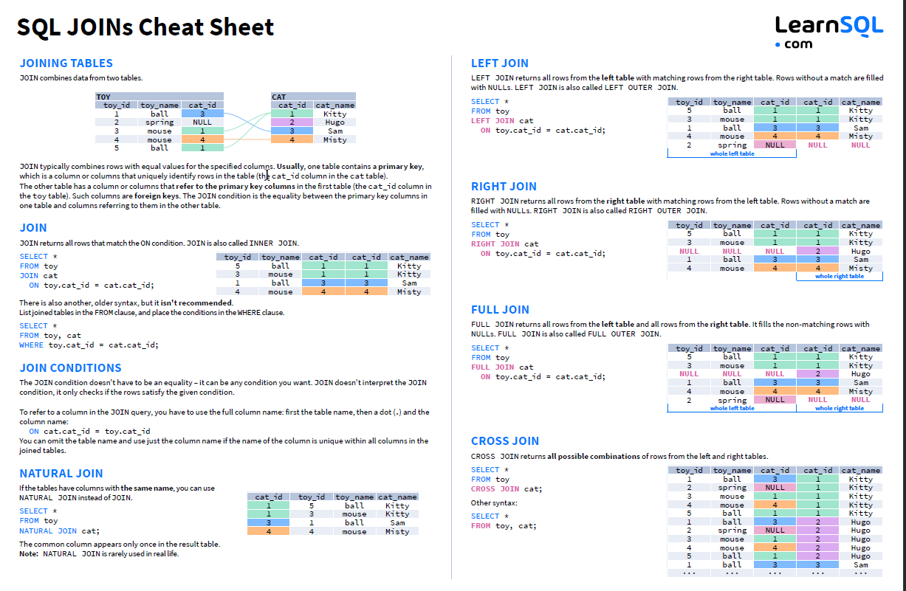

Today is the day 12 of my second internship in Bosch headquarters office in Maltepe - İstanbul. I am continuing the explanation of join types. Between these join types, I have selected left outer join, which mean that between two tables, all rows from table 1 and matching rows from table 2. The reason that I selected left outer join is that the table 1 only contain unique values. Thus, I need to get all values from table 1, then I need to get extra columns from table 2 if there is a match. After this I repeated the process for table 2 and table 3. The hierarchical situation was similar. Then, as finally I repeated the process between table 3 and table 4. In the result, we have merged 4 tables with left outer join method. At this point, I had a table in power query data editor. I saved it as a connection, hence did not export the data as table or pivot table. But after then, I exported the master table as pivot table report. (There are also other options to export as) But before this, I filtered the data in power query data editor. Because I have tried to export all of the data previously but did not work. One of the reasons that the tables are separated I think is that the Excel has a maximum row number. When I tried to export the whole master table to a worksheet, I got an error. I think combining tables (merging) has increased row numbers and the number has exceeded maximum row numbers. Thus, in power query data editor, I have pre-filtered the data based on conditions. Row number reduced in more than 60-70 percent and I started exporting filtered data as pivot table report. After this, I have one new worksheet with pivot table report now. I need to get the count of different combinations. At this point, I could not think of a practical solution thus as a short time solution, I added an IF function in a new column at the end of pivot table. This column looks for a certain column(s) in pivot table and writes 1 if it satisfies the conditions, and writes 0 if the conditions are not satisfied. Thus, there is a new column with 1 and 0 values. This corresponds to one conditions, I have added multiple AND and OR logic conditions with numerical conditions. After this, I added a AUTOSUM function at lower end of the column and added 1 values. The responding value was the count of this combination. I think there may be very practical solutions for this situation, but I could not find it and used a temporary solution. I repeated this IF and SUM column for 9 times for all conditions and recorded count numbers. Then, I wrote them in a mail and attached the Excel file and other files. I also used a different viewpoint at first and wrote that as method 1 and I wrote the method that I specified above as method 2. Feedback was that the approach in method 2 was correct and we were continuing to a new task. These weeks were challenging for me because I had more lack of information about how Excel works, functions and pivot tables. I am happy that the task 1 is completed and we are continuing to task 2.

Today is the day 13 of my second internship in Bosch headquarters office in Maltepe - İstanbul. In the following pages, I aim to show the information that I have researched in different Excel formulas:

**1. SUM**

The SUM function is the first must-know formula in Excel. It usually aggregates values from a selection of columns or rows from your selected range.

**=SUM(number1, [number2], …)**

**2. AVERAGE**

The AVERAGE function should remind you of simple averages of data such as the average number of shareholders in a given shareholding pool.

**=AVERAGE(number1, [number2], …)**

**3. COUNT**

The COUNT function counts all cells in a given range that contains only numeric values.

**=COUNT(value1, [value2], …)**

**4. COUNTA**

Like the COUNT function, COUNTA counts all cells in a given rage. However, it counts all cells regardless of type. That is, unlike COUNT that relies on only numerics, it also counts dates, times, strings, logical values, errors, empty string, or text.

**=COUNTA(value1, [value2], …)**

**5. IF**

The IF function is often used when you want to sort your data according to a given logic. The best part of the IF formula is that you can embed formulas and function in it.

**=IF(logical_test, [value_if_true], [value_if_false])**

**6.TRIM**

The TRIM function makes sure your functions do not return errors due to unruly spaces. It ensures that all empty spaces are eliminated. Unlike other functions that can operate on a range of cells, TRIM only operates on a single cell. Therefore, it comes with the downside of adding duplicated data in your spreadsheet.

**=TRIM(text)**

**7. MAX & MIN**

The MAX and MIN functions help in finding the maximum number and the minimum number in a pull of values.

**=MIN(number1, [number2], …)**

There are many more functions in Excel. Each function acts for a unique purpose. I need to find and use the required function in appropriate situation. For all functions in alphabetical order, the official page of Microsoft provides detailed information.

Today is the day 14 of my second internship in Bosch headquarters office in Maltepe - İstanbul. Today, I want to summarize my research and founded resources in RegEx. This module is very practical and helps us to find conditional string in a text. Similar to ctrl+f but with conditions.

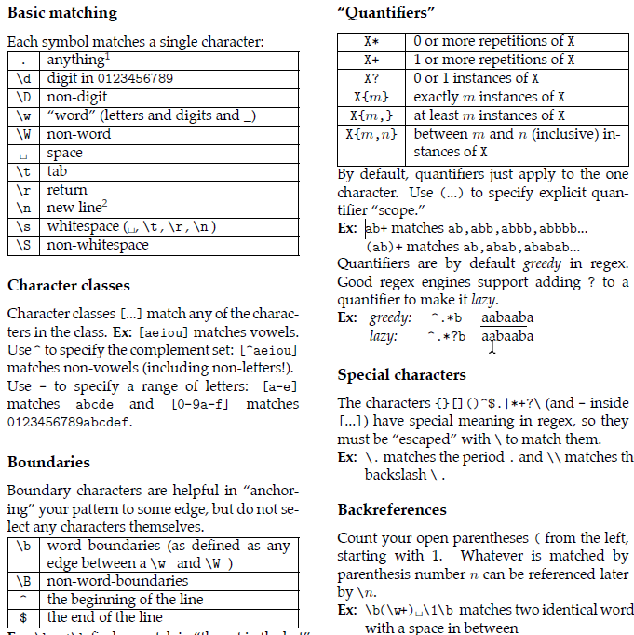

I very much like regex module, and I have used this module in my first internship to find patterns in a text data. Task was related to finding required data/value from a pdf based on labels and transferring values to an Excel file with python. Python as also pdf reading support for this task. I have trained on the training material in above, and learned some of the possible use cases of regex.

Today is the day 15 of my second internship in Bosch headquarters office in Maltepe - İstanbul. This day marks the half of my internship. I have prepared an introductory image to summarize the work areas that I have worked in automation. The file(image) is as following:

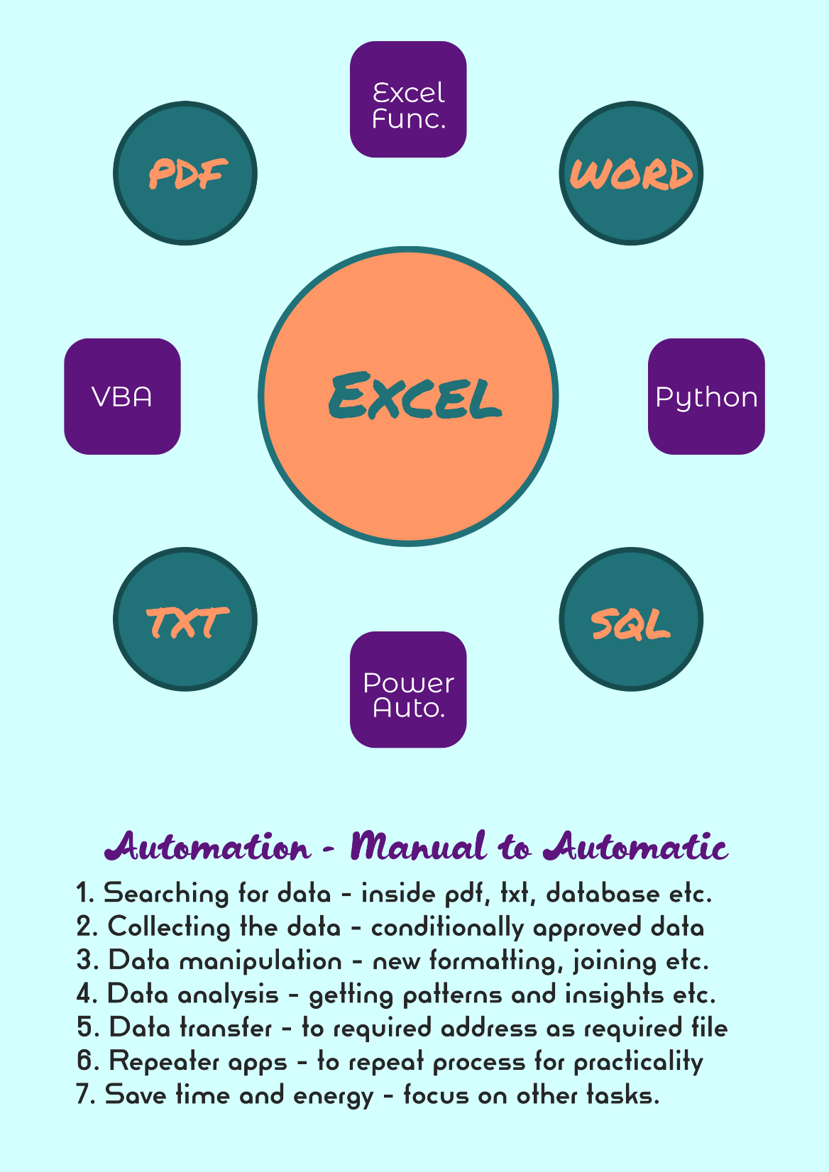

Today is the day 16 of my second internship in Bosch headquarters office in Maltepe - İstanbul. For a program, I have searched for a method to get username without opening a file, and I am writing the solution that I have come across:

import ctypes

def get_display_name():

GetUserNameEx = ctypes.windll.secur32.GetUserNameExW

NameDisplay = 3

size = ctypes.pointer(ctypes.c_ulong(0))

GetUserNameEx(NameDisplay, None, size)

nameBuffer = ctypes.create_unicode_buffer(size.contents.value)

GetUserNameEx(NameDisplay, nameBuffer, size)

return nameBuffer.value

print(get_display_name())

With this code, name and surname of the computer user if registered. Also I have written a code for a task where some sections of a string needs to be replaced with another string. The code is as:

from datetime import datetime

startTime = datetime.now()

import re

string = "{records#QUERY# { edges { node { id naicscode naicsdesc } } <need to place another string here> } }"

match = re.search("\{.*?\{.*?\{.*?\{.*?\}.*?(\}).*?(\}).*?\}",string)

idx1 = match.span(1)[0] # index of second "}"

idx2 = match.span(2)[0] # index of third "}"

print(string)

string = string[:idx1+1] + " " + "apple" + " " + string[idx2:]

print(string)

print("Program runtime: " + str(datetime.now()-startTime))

# This script operates on strings which have: {..{..{..{..}..}..}..}

# Program changes substring between second "}" and third "}"

Today is the day 17 of my second internship in Bosch headquarters office in Maltepe - İstanbul. Today, I have repeated my knowledge on the reference text I have written in the past, for MSSQL:

--To show all available datasets (*)

select name, database_id, create_date

from sys.databases;

-- To make a new database in the server

create database tutorial_database

-- To use a database (enter)

use tutorial_database;

-- To see all tables in a database

select * from tutorial_database.information_schema.tables;

-- To make a new table in database

create table tutorial_table

(

Date_Taken datetime,

Person_Name varchar(20),

Equipment_Name varchar(25),

Returned varchar(3)

)

-- To see all content from a table

select * from tutorial_table;

-- To add columns to a table

alter table tutorial_table

add return_date datetime;

-- To drop columns in a table

alter table tutorial_table

drop column return_date;

-- To add a row to the table

insert into tutorial_table(Date_Taken,Person_Name, Equipment_Name, Returned)

values('2022-09-01 22.30.10.15','Carter','ECU','No');

-- To delete a row from the table

delete from tutorial_table where Person_Name='Carter'

-- To delete contents inside a table

truncate table tutorial_table;

-- To delete a table in the database

drop table tutorial_table;

-- To switch to different database

use tempdb;

-- To delete a database in the server

drop database tutorial_database;

Some MYSQL codes does not work with MSSQL. Some parts of these only work in MSSQL.

Today is the day 18 of my second internship in Bosch headquarters office in Maltepe - İstanbul. Today and tommorrow, I have worked with a macro inside Excel VBA. I have prepared two buttons for automation.After some cells are selected, user needs to click take or give button to perform operations:

Sub Take_Equipment()

Dim active_cells As String

active_cells = Selection.Address

' Case 1: Single Cell - $C$3

' Case 2: Multiple Rows Adjacent - $C$3:$C$7

' Case 3: Multiple Cols Adjacent - $C$7:$E$7

' Case 4: Multiple Rows and Cols Adjacent - $C$5:$E$7

' Case 5: Multiple Non Adjacent Cells - $C$3,$D$5,$E$7

' Case 6: Multiple Non Adjacent But Adjacent Rows - $B$2:$B$3,$C$4:$C$5,$D$6:$D$7

' Case 7: Multiple Non Adjacent But Adjacent Cols - $B$2:$C$2,C$5$:D$5$,E$7$:F$7$

' Case 8: Multiple Non Adjacent But Adjacent Rows and Cols - $A$2:B$3$,B$5$:D$6$,D$8$:E$10$

' Case 9: Multiple Non Adjacent Cells and Groups - $A$2,$B$3:$B$4,$B$6:$C$6,C$8$:D$9$,$D$11,$E$13:$G$14

Dim regex As Object

Set regex = New RegExp

'---------------------------------------------------------------------------------------------------------

'-SECTIONBREAK-SECTIONBREAK-SECTIONBREAK-SECTIONBREAK-SECTIONBREAK-SECTIONBREAK-SECTIONBREAK-SECTIONBREAK-

'---------------------------------------------------------------------------------------------------------

' PreCase - Getting Full Name

Dim username As String

username = Application.username

regex.Pattern = "(?:FIXED-TERM?)\s(.*)\s\(.*\)"

Set Match = regex.Execute(username)

Dim full_name As String

full_name = Match(0).SubMatches(0)

'---------------------------------------------------------------------------------------------------------

'-SECTIONBREAK-SECTIONBREAK-SECTIONBREAK-SECTIONBREAK-SECTIONBREAK-SECTIONBREAK-SECTIONBREAK-SECTIONBREAK-

'---------------------------------------------------------------------------------------------------------

' PreCase - Getting Name and Surname

regex.Pattern = "(.*?)\s(.*)"

Dim name, surname As String

Set Match = regex.Execute(full_name)

surname = Match(0).SubMatches(0)

name = Match(0).SubMatches(1)

full_name = name & " " & surname ' We found the full name of the user

'---------------------------------------------------------------------------------------------------------

'-SECTIONBREAK-SECTIONBREAK-SECTIONBREAK-SECTIONBREAK-SECTIONBREAK-SECTIONBREAK-SECTIONBREAK-SECTIONBREAK-

'---------------------------------------------------------------------------------------------------------

' PreCase - Getting Date

Dim date_time As String

date_time = Date ' We found the date of recording

'---------------------------------------------------------------------------------------------------------

'-SECTIONBREAK-SECTIONBREAK-SECTIONBREAK-SECTIONBREAK-SECTIONBREAK-SECTIONBREAK-SECTIONBREAK-SECTIONBREAK-

'---------------------------------------------------------------------------------------------------------

' PreCase - Getting Target Column Indices

Dim name_index, date_index As Integer

name_index = Columns("H").Column

date_index = Columns("F").Column

'---------------------------------------------------------------------------------------------------------

'-SECTIONBREAK-SECTIONBREAK-SECTIONBREAK-SECTIONBREAK-SECTIONBREAK-SECTIONBREAK-SECTIONBREAK-SECTIONBREAK-

'---------------------------------------------------------------------------------------------------------

' Case Work - Disecting Cell Selection Address(es)

Dim ranges() As String

Today is the day 19 of my second internship in Bosch headquarters office in Maltepe - İstanbul. I continued my work on the code in day 18:

ranges = Split(active_cells, ",")

'---------------------------------------------------------------------------------------------------------

'-SECTIONBREAK-SECTIONBREAK-SECTIONBREAK-SECTIONBREAK-SECTIONBREAK-SECTIONBREAK-SECTIONBREAK-SECTIONBREAK-

'---------------------------------------------------------------------------------------------------------

Dim row_number As Integer

Dim row_start, row_finish As Integer

Dim col_start, col_finish As String

'---------------------------------------------------------------------------------------------------------

'-SECTIONBREAK-SECTIONBREAK-SECTIONBREAK-SECTIONBREAK-SECTIONBREAK-SECTIONBREAK-SECTIONBREAK-SECTIONBREAK-

'---------------------------------------------------------------------------------------------------------

' Case Work - Entering Main Loop for Address(es)

Dim range As String

For i = LBound(ranges()) To UBound(ranges())

range = ranges(i)

Count = Len(range) - Len(Replace(range, "$", "")) ' Count of $ characters in address

'---------------------------------------------------------------------------------------------------------

'-SECTIONBREAK-SECTIONBREAK-SECTIONBREAK-SECTIONBREAK-SECTIONBREAK-SECTIONBREAK-SECTIONBREAK-SECTIONBREAK-

'---------------------------------------------------------------------------------------------------------

' Case Work - Operations for Address Type 1: $B$3 or $BZ$35 or with bigger row numbers

If Count = 2 Then

regex.Pattern = "\$(?:[A-Z]{1,2})\$([0-9]+)"

Set Match = regex.Execute(range)

row_number = Match(0).SubMatches(0)

Cells(row_number, name_index) = full_name

Cells(row_number, name_index).HorizontalAlignment = xlCenter

Cells(row_number, name_index).VerticalAlignment = xlCenter

Cells(row_number, name_index).Font.Bold = True

Cells(row_number, date_index) = date_time

Cells(row_number, date_index).HorizontalAlignment = xlCenter

Cells(row_number, date_index).VerticalAlignment = xlCenter

Cells(row_number, date_index).Font.Bold = True

'---------------------------------------------------------------------------------------------------------

'-SECTIONBREAK-SECTIONBREAK-SECTIONBREAK-SECTIONBREAK-SECTIONBREAK-SECTIONBREAK-SECTIONBREAK-SECTIONBREAK-

'---------------------------------------------------------------------------------------------------------

' Case Work - Operations for Address Type 2: $B$3:$C$5 or $B$3:$BD$40 or with bigger row numbers

ElseIf Count > 2 Then

regex.Pattern = "\$([A-Z]{1,2})\$([0-9]+)\:\$([A-Z]{1,2})\$([0-9]+)"

Set Match = regex.Execute(range)

col_start = Match(0).SubMatches(0)

col_finish = Match(0).SubMatches(2)

row_start = Match(0).SubMatches(1)

row_finish = Match(0).SubMatches(3)

' First sub-type of this type of address (Adjacent rows)

If col_start = col_finish Then

For ii = row_start To row_finish

Cells(ii, name_index) = full_name

Cells(ii, name_index).HorizontalAlignment = xlCenter

Cells(ii, name_index).VerticalAlignment = xlCenter

Cells(ii, name_index).Font.Bold = True

Next ii

Today is the day 20 of my second internship in Bosch headquarters office in Maltepe - İstanbul. Today I worked on refactoring a VBA code that was written by a former employer. Some part of my code:

Private Sub CommandButton1_Click()

'-----------------------------------------------------------------------------------------------------------------

'-PREPROCESSING-PREPROCESSING-PREPROCESSING-PREPROCESSING-PREPROCESSING-PREPROCESSING-PREPROCESSING-PREPROCESSING-

'-----------------------------------------------------------------------------------------------------------------

Dim twb_wb_path As String ' Path of this workbook

Dim xls_wb_path As String ' Path of .xls workbook

Dim dcm_wb_path As String ' Path of .dcm workbook

Dim xml_wb_path As String ' Path of .xlm workbook

Dim twb_wb_name As String ' Name of this workbook

Dim xls_wb_name As String ' Name of .xls workbook

Dim dcm_wb_name As String ' Name of .dcm workbook

Dim xml_wb_name As String ' Name of .xlm workbook

'-----------------------------------------------------------------------------------------------------------------

'-PREPROCESSING-PREPROCESSING-PREPROCESSING-PREPROCESSING-PREPROCESSING-PREPROCESSING-PREPROCESSING-PREPROCESSING-

'-----------------------------------------------------------------------------------------------------------------

twb_wb_path = Application.ActiveWorkbook.FullName

xls_wb_path = Application.GetOpenFilename(FileFilter:="Text Files (*.XLS), *.XLS", Title:="Select XLS File")

dcm_wb_path = Application.GetOpenFilename(FileFilter:="Text Files (*.dcm), *.dcm", Title:="Select DCM File")

xml_wb_path = Application.GetOpenFilename(FileFilter:="Text Files (*.XML), *.XML", Title:="Select XML File")

'-----------------------------------------------------------------------------------------------------------------

'-PREPROCESSING-PREPROCESSING-PREPROCESSING-PREPROCESSING-PREPROCESSING-PREPROCESSING-PREPROCESSING-PREPROCESSING-

'-----------------------------------------------------------------------------------------------------------------

' Check if all paths are submitted, if not exit the program

If dcm_wb_path = "False" Or xml_wb_path = "False" Then

MsgBox (" One or more files have not been submitted. Exiting the program."): Exit Sub

End If

This part of the code asks user for multiple files and gives an error message if one or more files are not submitted. Also, this code gets the current Excel file’s name.

Today is the day 21 of my second internship in Bosch headquarters office in Maltepe - İstanbul. I have continued on VBA code which was in day 20. The non confidential part I can share is as:

Application.DisplayAlerts = False

twb_wb_name = Application.ActiveWorkbook.Name ' Name of this workbook

xls_wb_name = get_filename(xls_wb_path) ' Name of .xls workbook

dcm_wb_name = get_filename(dcm_wb_path) ' Name of .dcm workbook

xml_wb_name = get_filename(xml_wb_path) ' Name of .xml workbook

'-----------------------------------------------------------------------------------------------------------------

'-PREPROCESSING-PREPROCESSING-PREPROCESSING-PREPROCESSING-PREPROCESSING-PREPROCESSING-PREPROCESSING-PREPROCESSING-

'-----------------------------------------------------------------------------------------------------------------

Application.ScreenUpdating = True

'-----------------------------------------------------------------------------------------------------------------

'-PREPROCESSING-PREPROCESSING-PREPROCESSING-PREPROCESSING-PREPROCESSING-PREPROCESSING-PREPROCESSING-PREPROCESSING-

'-----------------------------------------------------------------------------------------------------------------

Application.DisplayAlerts = True

MsgBox "Pre-Processing was completed", vbInformation

End Sub

'-----------------------------------------------------------------------------------------------------------------

'-FUNCTIONS-FUNCTIONS-FUNCTIONS-FUNCTIONS-FUNCTIONS-FUNCTIONS-FUNCTIONS-FUNCTIONS-FUNCTIONS-FUNCTIONS-FUNCTIONS---

'-----------------------------------------------------------------------------------------------------------------

Function get_filename(path As String) As String

Dim fso As Object: Set fso = CreateObject("Scripting.FileSystemObject"): get_filename = fso.GetFilename(path)

End Function ' Gets file name from a file path

* The code is completed but not tested. I hope to test previous version and my version in following days.

Today is the day 22 of my second internship in Bosch headquarters office in Maltepe - İstanbul. With my work friend’s recommendation I have started using Power Automate for automation tasks. This tool is very advanced and required less to none coding to make a workflow. I have made a new flow (process) in power automate. This flow gets tables from pdf and writes in Excel in similar format:

**Note:** The program only works in Turkish language. Thus, attached screenshot have Turkish labels.

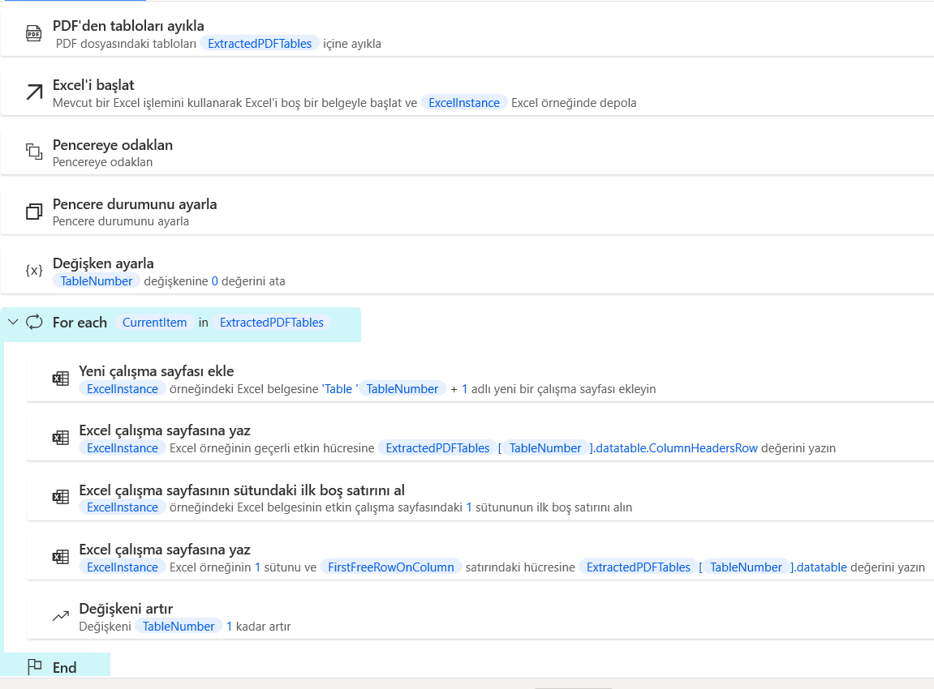

I very much liked this program as well. The interface is user friendly, sample processes and purposes have much variety and it is very practical and more minimalistic to make a automation bot.

Today is the day 23 of my second internship in Bosch headquarters office in Maltepe - İstanbul. In my past internship, I made an automation program for a task. In these days, I got feedback that this program does not work when additional filters are applied after program process is completed. I also wanted to make a new version of this program thus, I have started to work on the script.

# Calculations

if len(fol_nums) == 3:

if fol_nums[2] == "#":

fol_nums = list(range(int(fol_nums[0]),int(fol_nums[1])+1))

fol_nums = [str(num) for num in fol_nums]

# Calculations

rep_lrh = [[key,key.lower(),key.title(),key.upper()] for key in rep_lrh]

rep_lrh = [item for sublist in rep_lrh for item in sublist]

# Input Operations

dir_file = os.listdir(inp_path)

inp_fold = [name for name in dir_file if name.startswith(tuple(fol_nums))]

cdr_path = [os.path.join(inp_path, name, cdr_name) for name in inp_fold]

# Counter

counter = 0

# File Loop for Specified Folder Contents

for main_path in cdr_path:

report_file = [file for file in os.listdir(main_path) if rep_key in file]

result_file = [file for file in os.listdir(main_path) if res_key in file]

if len(report_file) == 0: continue

report = report_file[0]

report_path = os.path.join(main_path, report)

wb_rep = op.load_workbook(report_path)

ws_rep = wb_rep[rep_wsn]

Some parts of the code I was working with was similar to this. I can not place the whole code in here because the space is limited.

Today is the day 24 of my second internship in Bosch headquarters office in Maltepe - İstanbul. Today I have continued day 23 code. Some parts of the code is as:

# SFSN - Same folder same name

# SFWE - Same folder with extension

# SFDN - Same folder different name

# DFSN - Different folder same name 111

# DFWE - Different folder with extension

# DFDN - Different folder different name

if ope_mode == "SFSN":

save_path = report_path

elif ope_mode == "SFWE":

save_path = os.path.join(main_path,report.split(".")[0]+"_"+ext_file+".xlsx")

elif ope_mode == "SFDN":

save_path = os.path.join(main_path,out_filn+".xlsx")

elif ope_mode == "DFSN":

fold_path = os.path.join(out_path, out_foln)

if os.path.exists(fold_path) and counter==0: sh.rmtree(fold_path)

if not os.path.exists(fold_path): os.mkdir(os.path.join(fold_path))

save_path = os.path.join(fold_path, report)

counter += 1

elif ope_mode == "DFWE":

fold_path = os.path.join(out_path, out_foln + "_" + ext_fold)

if os.path.exists(fold_path) and counter==0: sh.rmtree(fold_path)

if not os.path.exists(fold_path): os.mkdir(fold_path)

save_path = os.path.join(out_path, out_foln + "_" + ext_fold, \

report.split(".")[0] + "_" + ext_file + "_" + fol_nums[counter] + ".xlsx")

counter += 1

elif ope_mode == "DFDN":

fold_path = os.path.join(out_path, out_foln)

if os.path.exists(fold_path) and counter==0: sh.rmtree(fold_path)

if not os.path.exists(fold_path): os.mkdir(fold_path)

save_path = os.path.join(fold_path,out_filn+"_"+fol_nums[counter]+".xlsx")

counter += 1

Today is the day 25 of my second internship in Bosch headquarters office in Maltepe - İstanbul. I am getting closer to the end of my internship. Today, I have tried to give my opinion on various situations that shared about python in our community page. One person was asking that if using a conda environment as a native python installation is possible. In my opinion, conda and pip are different module managers, and I have found out that using them together as mixed is not recommended. I wrote the following response to this question:

Hello, before expert help; please look at these questions and documentation links inside:

* https://stackoverflow.com/questions/71080853/create-virtual-environment-with-native-python-w-out-conda
* https://stackoverflow.com/questions/45718044/python-libraries-managed-by-conda-and-native-python
* https://stackoverflow.com/questions/24664435/use-the-default-python-rather-than-the-anaconda-installation-when-called-from-th

From what I know, avoiding Conda while making a native environment is possible with cmd- pip. But I do not know how to use an existing conda environment while avoiding conda.

Another person was thinking about the error that he received which is related to 'charmap' like Error while importing an installed package in anaconda. I have researched this issue and wrote:

Hello, this might be an issue with latin-1 and utf-8 encoding, which is discussed in the link: (You may need to change encoding type when opening a text file for example)

* https://stackoverflow.com/questions/9233027/unicodedecodeerror-charmap-codec-cant-decode-byte-x-in-position-y-character

At the rest of the day, I have tried to follow other work related tasks and meetings.

Today is the day 26 of my second internship in Bosch headquarters office in Maltepe - İstanbul. Today, I met with another developer in Quality department. He was working in automation of word file data, outlook email’s and pdf’s. He posted a question to make a word file editor with an interface. I replied with a response, some parts of my response are:

In short, what modules you need to install are:

* python-docx (Documentation)        🔢You may edit or produce word files with this module.
* tkinter (Documentation)                  🔢You may make a GUI with fillable areas, buttons with this module.
* pyinstaller (Documentation)            🔢You may make an executable file to share your program with users. (optional)

Let's go step by step in this purpose:

1. If you have not done before, make a new python environment. From Anaconda navigator, environment tab; in bottom you may select the button to produce a new environment. Make sure you select default python version (not latest, may be 3.9.12 for example). Afterwards, in home tab, select your environment and install spyder. (or VS code if not installed)
   * Using Anaconda Navigator to make a new environment, you may also install default extra modules, that you may not need.
   * To avoid that you may use cmd to make a new python environment.
   * To do that, open cmd; and type the following line: conda create --name my_env python
   * Then type: conda activate my_env
   * If you want to install spyder, type conda install spyder
   * Repeat conda install module_name for any other modules you want to install
   * To update all modules inside env, optionally type: conda update --all
   * Come back to Anaconda Navigator, select your new environment, launch an IDE to start coding.
2. Now you need to install additional modules. (except pyinstaller for now) To do that, open Anaconda Navigator environment tab and in not installed area, search for "tk" module. (python-docx not availablein navigator) But I would suggest, using cmd again to find and install the package more easily. But in other cases, using navigator to look for module descriptions is a good option. To install modules in cmd:
   * Open cmd again
   * Type: conda activate my_env
   * Type: conda install tk                                                (follow additional prompts like entering y)
   * Type: conda install -c conda-forge python-docx      (follow additional prompts like entering y)
   * Optionally, type: conda list                                        (to check all modules in environment)
3. If you done previous steps, open an IDE of your choice and start using python-docx and tkinter by importing them in a new script. You may see how to use them in documentations and support sites. In your script you need to write a code to show a GUI (using tkinter) to maybe get values from user and start process in your script by clicking button (for example) Once the button is clicked, process should use docx module to edit the word document in specified path. Based on your requirements, you may need to make a different script. Again, searching how to use these modules is recommended. Personally, I would suggest you to especially look into grid attribute in tkinter module and using built-in modules (such as os, shutil to save file, delete folder etc.) if needed. (You may need it to save word file after edited)

Today is the day 27 of my second internship in Bosch headquarters office in Maltepe - İstanbul. From day 26, I continued my response and answered a question with other work related tasks.

1. Assume, you wrote your code. When worked, a GUI comes, and after process has been started, necessary operations are done. Now, your task is completed at this step. But I wrote pyinstaller for one purpose. Suppose that you want to share this program with different user who do not have python installed in their computer, or make an executable file in your computer to work the program without starting python. For these cases, you may make a .exe (executable) file from your python script, using pyinstaller. Before that, you may need to make a new environment with minimum modules. (For example, if you use your base environment you may get an executable file with +300 mb size, this is not wanted) To make a new environment with minimum modules: (without spyder)
   * Open cmd again
   * type: conda create --no-default-packages -n build_env python
   * type: conda activate build_env
   * type: conda install pyinstaller (if cant find, type: conda install -c conda-forge pyinstaller )
   * type: conda install tk
   * type: conda install -c conda-forge python-docx
   * copy the path of your script file: (for example: C:/User......../FolderName/word_editor.py)
   * type: pyinstaller (to make sure it is installed and to see options)
   * type: pyinstaller "your_path" --name program_name --onefile
   * after process is fully completed, you may see in logs, a path where your executable file has been made. This may be U:\dist , but check logs in cmd to get an idea. Another way is that to type: cd directory_path and then writing word_editor.py instead of "your_path" in previous step. If done like this, you may see output folders are in the same directory with your scriot.
   * Open dist folder, you may see an executable file. Now, run it. If GUI did not come to you, then there may be an error in console window that appeared. Record screen while running the executable, and watch later to see what went wrong. For example lets assume in final lines you see a similar string: ModuleNotFoundError:No module named: 'openpyxl.cell._writer'
   * You have several options, one of them is adding a line in your script as(in example case): from openpyxl.cell import_writer. And making the executable again. (I did not test this method)
   * Or you may delete dist folder, come back to cmd, and type: pyinstaller "your_path" --name program_name --onefile -w --hidden-import=openpyxl.cell._writer  (Do not add -w if you are unsure)
   * Now test your new executable file again, if you can  see GUI appeared, or if you did not get any errors, this may mean that you can send this executable file to users. (Make a user guide as well)

I have used openpyxl module to make an automation program with tkinter, pyinstaller whih operates on excel files.Communicate with me for further discussion. I would appreciate to learn a practical usage of this python-docx module. With regards...

After this response another person asked me that do we need to use the same environment when developing the code and transforming into an executable file. I replied with that a developer do not need to use the same environment for both tasks. But personally I recommend using a development environment and an empty as possible environment to reduce the file size of resulting .exe file.

Today is the day 28 of my second internship in Bosch headquarters office in Maltepe - İstanbul. Today I have prepared code lines for different tasks. Some code scripts are as:

---------------------------------------------------------------------------------------------------------------------------

lines = data_to_parse.splitlines()

components = [line.split(':')[1].strip() for line in lines if 'Components' in line]

path = [line.split(':')[1].strip() for line in lines if 'Path' in line]

result_list = [{components[i]:path[i]} for i in range(len(components))]

---------------------------------------------------------------------------------------------------------------------------

import pandas as pd

df = pd.read_csv(r"path")

df = df.sort_values(by=['state'])

df.reset_index(drop = True, inplace = True)

# we know state is in column 3

states = list(dict.fromkeys(df.iloc[:,3].tolist()))

rows = [[i for i in range(df.shape[0]) if df.iloc[i,3]==s] for s in states]

temp = [[i2 for i2 in range(len(rows[i]))] for i in range(len(rows))]

into = [inner for outer in temp for inner in outer]

df.insert(4, "No", into)

df.set_index(pd.MultiIndex.from_arrays([df.iloc[:,no] for no in [3,4]]),inplace=True)

df.drop(df.columns[[3,4]], axis=1, inplace=True)

dfs = [df.iloc[row,:] for row in rows]

for i in range(len(dfs)): dfs[i] = dfs[i]\

.melt(var_name="app",ignore_index=False).set_index("app",append=True)

def call(df):

if df.index.nlevels == 1: return df.to_dict()[df.columns[0]]

return {key: call(df_gr.droplevel(0, axis=0)) for key, df_gr in df.groupby(level=0)}

data = {}

for i in range(len(states)): data.update(call(dfs[i]))

---------------------------------------------------------------------------------------------------------------------------

def compare(self, mydict):

for list1 in mydict.values():

for list2 in mydict.values():

if not list1 == list2:

# return false, give warning, break etc.

---------------------------------------------------------------------------------------------------------------------------

Today is the day 29 of my second internship in Bosch headquarters office in Maltepe - İstanbul. I have continued to make different scripts for different tasks:

---------------------------------------------------------------------------------------------------------------------------

chip_list = [player[5] for player in player_list]

idx_list = []

for index, chip in enumerate(chip_list):

i_num = len(player_list)-1

for index2, chip2 in enumerate(chip_list):

if chip > chip2:

i_num = i_num-1

idx_list.append(i_num)

final_list = [0 for i in range(len(player_list)) ]

for i,idx in enumerate(idx_list):

final_list[idx] = player_list[i]

---------------------------------------------------------------------------------------------------------------------------

for index in range(ws.min_row, ws.max_row):

row_level = ws.row_dimensions[index].outline_level + 1

---------------------------------------------------------------------------------------------------------------------------

my_dict = {(df.iloc[i,0],df.iloc[i,1]): df.iloc[i,2] for i in range(len(df))}

---------------------------------------------------------------------------------------------------------------------------

number = int(input("Enter a positive number to find factors: "))

factor = [num for num in range(1,number+1) if number % num == 0]

for fac in factor: print(f"{fac} is a factor of {number}")

---------------------------------------------------------------------------------------------------------------------------

a XFormObject is (Also named as Form XObject) an advanced feature of PDF files. These objects may have their own resources such as images and fonts. Currently, it looks as PdfReader does not have capacity to read such objects. If you are only interested in text in Pdf file, you may ignore this warning and use the output you have gathered. But I would also suggest you to look at Java pdf read methods about this issue.

---------------------------------------------------------------------------------------------------------------------------

f you are using conda, enter these lines in cmd:

conda activate your_env_name

conda install pycrypto

If you are using pip, upload the module via pip. After installed, try again to see if you are getting the same error.

---------------------------------------------------------------------------------------------------------------------------

With these answers that I have written, I close this section of the internship paper.

Today is the final day of my second internship in Bosch headquarters office in Maltepe - İstanbul. I want to add the graphic related jobs in my last page. I have prepared these images. (graphic design) These are used in a presentation. I attach some of my graphical works:











There are several more graphical works I have prepared. As a last note in my internship, my 2 internships helped me very much. I am doing the job I like. In data analysis, data visualization, automation, machine learning, deep learning, different softwares and programming languages; I have learned valuable information, my colleagues were very helpful to me and I am very happy to work in this work area. In future, if required I may approach aviation companies with data related job titles. Thus, this internship helped me to get the knowledge about these work areas in general.